IMAT3451 Final Year Project Periodic Progress Report (PPR)

Programme/Course Title: Computer games programming

Name: Connor Rowland Assessment Period: week 21

Project Title: Dobble Report Number: 7

Objectives for Period: (refer to previous report)
Complete all work for sprint 4.

Summary of Progress for Period: (identify evidence of progress)
All work more or less complete

Problem Areas and Suggested Solutions:

Objectives, Deliverables & Plan for Next Period:
Have a work prototype of the game.

Date of Next Review: 10am 7th March

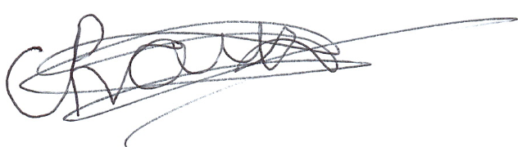
Student’s Signature: Date: 21/02/2019
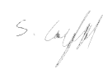

Supervisor’s Signature: Date: 21/02/2019

Comments (if any):

